1. ***Why would you choose a database system instead of simply storing data in operating system files? When would it make sense not to use a database system? (15 pts.)***

We have a following characteristics of the database system versus the file storage system:

* *Self-describing nature of a database system:*
* A database system not only contains the database, but also the definition of the structure and its constrains, usually called as Database catalog.
* Since generic structure stored in the catalog, it is easy for multiple applications to interact with the database.
* In file storage system, the data definition is a part of the application itself. Hence, these programs are constrained to work only with one database, whose structure has been defined in the application itself with the help of class and structures.
* *Insulation between programs and data, and data abstraction:*
* In file processing, the structure of data files is embedded in the application programs itself. In short, if we try to change the structure of the data file, then the program also has to be corrected with respect to the same.
* In database system, the structure of database is stored in Database Catalog separately from access of the programs. This is called program-data independence.
* In some database systems, a user can define operations on data as a part of database definition. This is called program-operation independence.
* Together, these independence characteristics is called data abstraction characteristic which is provided by database systems.
* *Support of multiple views of the data:*
* A view maybe a subset of database or it may contain virtual data that is derived from database files. An application can be provided with a specific view based on its requirements. By this, data also kept secure with the help of views in database systems.
* Support of views is not possible with file processing systems.
* *Sharing of data and multiuser transaction processing:*
* In database systems, the data files can be shared with multiple users at the same time, with a concurrency control software to ensure update of same data at the same time in a controlled manner.
* In file processing, we might still need to have a concurrency control software separately such that the program runs efficiently. It also can lead to security threats.

We would use file processing systems during following scenarios:

* When we use well-defined simple database applications which might not change at all.
* Application programs with fast, real-time requirements where DBMS overhead would be crucial.
* Embedded systems with less resources for storage.
* No multiple-user access to data.

1. ***Define the term DBA and what are the responsibilities of a DBA? (15 pts.)***

The individual who administers the responsibility of the database environment resources like the database, database management system and their related software is called as the Database Administrator (DBA).

The responsibilities of a DBA are as follows:

* Authorizing access to the database.
* Coordinating and monitoring the database usage.
* Acquiring software and hardware resources as needed for the database system.
* Accountable for different problems like security breaches and poor system response time.

1. ***Define the following terms (15 pts.)***

* ***DBMS –*** Collection of programs that helps users to create and maintain a database is termed as database management system. It can also be defined as a generic software system that facilitates the process of defining, constructing, manipulating and sharing databases among various users and applications.
* ***Database –*** A database is a collection of related data. It represents a part of the real-world called the mini world or the universe of discourse. Here data refers to known facts that can be recorded and have implicit meaning.
* ***Meta-data –*** The information stored in the DBMS Catalog, which describes the structure of the primary database is called as meta-data.
* ***Persistent object –*** When a complex object in object-oriented programming languages like C++ or Java is stored in object-oriented DBMS, to survive the termination of program execution and can later directly be retrieved by another object-oriented program is termed as a persistent object.
* ***Transaction –*** It is an executable program or a process that includes one or more database access. These access could be read, update, insertion or even deletion of records.

1. ***What are the different types of database end users? Discuss the main activities of each (15 pts.)***

The different types of database end users are as follows:

* Casual end users:

They are the casual users who occasionally access the database and might need different information every time. Their main activity is to use sophisticated database query language to specify their requests. Such users are usually high level managers.

* Naive or Parametric end users:

Major portion of end users whose main activity revolves around constantly quering and updating the database using canned transactions. Canned transactions are standard type of queries to follow a particular action.

* Sophisticated end users:

These users are usually the scientists, engineers or business analysts, who build application over one or more database. Their main activity is to familiarize the facilities of the DBMS in order to develop their own application, to meet all application requirements.

* Standalone users:

These users use personal separate databases where ready-made program packages provide easy to use menu based or graphic based interfaces.

1. ***Discuss the differences between database systems and information retrieval systems (10 pts.)***

|  |  |
| --- | --- |
| ***Database Systems*** | ***Information Retrieval System*** |
| Data is structured and formatted. | Data is indexed, catalogued and annotated using keywords. |
| Data from routine applications. | Data from books, manuscripts and various forms of library-based articles. |
| Used in industries where structured data is collected through forms. | Used in searching of materials based on the keywords, dealing with document processing and free form text processing. |
| Usage: Customer Relationship Management Software, Enterprise Resource Planning Software | Usage: Natural Language Processing, Image Processing |

1. ***Specify all the relationships among the records of the database shown in the following figure. (30 pts.)***

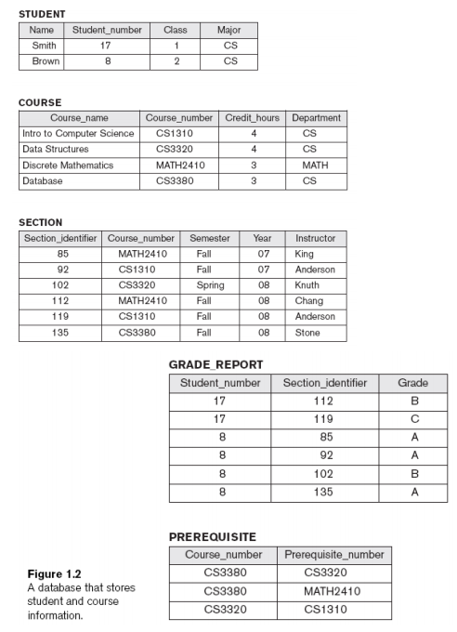

Relationships:

1. Course_number attribute of Section Entity is a foreign key mapped to Course_number of Course Entity.

Example: Instructor King was assigned a section 85 for Discrete Mathematics, a 3 Credit Hour course of Math Department in Fall 07.

1. Student_number attribute of Grade Report Entity is a foreign key mapped to Student_number of Student Entity and Section_identifier attribute of Grade Report Entity is a foreign key mapped to Section_identifier of Section Entity.

Example: Student Smith of Class 1 majoring in CS, secured grade ‘B’ in Discrete Mathematics, a 3 Credit Hour Course of Math Department under Instructor Chang in Fall 08, Section 112.

1. Both attributes of Prerequisite Entity that is Course_number and Prerequisite_number attributes are foreign keys of Course_number attribute of Course Entity.

Example: Database, a 3 Credit hour course of CS Department has a prerequisite course of Data Structures, a 4 credit hour course of CS Department.

**References:**

* Fundamentals of Database Systems, Sixth Edition by Elmasri, Navathe.